ORDER ATTACHMENT – MAGENTO 2

USER GUIDE

Table Of Contents

Preface ......................................…………………………………..…......3

Installation..….………………………………………………………………………..4

option1.............................................................................4

option2……………................................................................5

Backend Example ……………………………………………………….....……...6

Extension Configuration…………………………………….…………………….6

Frontend Example……...………………………………………………….……....9

Preface :

* Magento 2 Order Attachment allows customers to upload files such as Images, PDF, word documents, excel documents and many other attachments while placing the orders.

* Magento 2 Order Attachment allows customers to Drag & drop
Functionality for upload documents.

* Magento 2 Order Attachment allows Admin can manage Attachments Size, Type, Limit of attachment per order

* Magento 2 Order Attachment allows Admin to send Attachments in email.

Installation:

There are two ways of installing extension in magento2.

1) Using COMMAND LINE.
2) Manually install extension.

Option 1: Magento 2 install extension using COMMAND LINE (Recommended).

Follow below steps to install extension from the command line.

Step 1: Download the extension and unzip it.

Step 2: Upload it to code directory in your magento installation’s app directory.
If code directory does not exists then create.

Step 3: Disable the cache under System → Cache Management.

Step 4: Enter the following at the command line:
php bin/magento setup:upgrade
php bin/magento setup:static-content:deploy

Step 5: Once you complete above steps log out and log in back to the admin
panel and switch to Stores → Configuration → Mageants → OrderAttachment.

The module will be displayed in the admin panel.

Option 2: Magento 2 install extension manually.

Step 1: Download the extension and unzip it.

Step 2: Upload it to code directory in your magento installation’s app directory.
If code directory does not exists then create.

Step 3: Disable the cache under System → Cache Management Edit
app/etc/config.php file and add one line code:
‘Mageants_OrderAttachment label’ → 1

Step 4: Disable the cache under System → Cache Management

Step 5: Once you complete above steps log out and log in back to the
admin panel and switch to Stores → Configuration → Mageants →
Mageants_OrderAttachment, the module will be displayed in the admin panel.

Backend example :

After Installation of Extension login to Magento admin panel to set
configuration of the extension.

Extension Configuration :

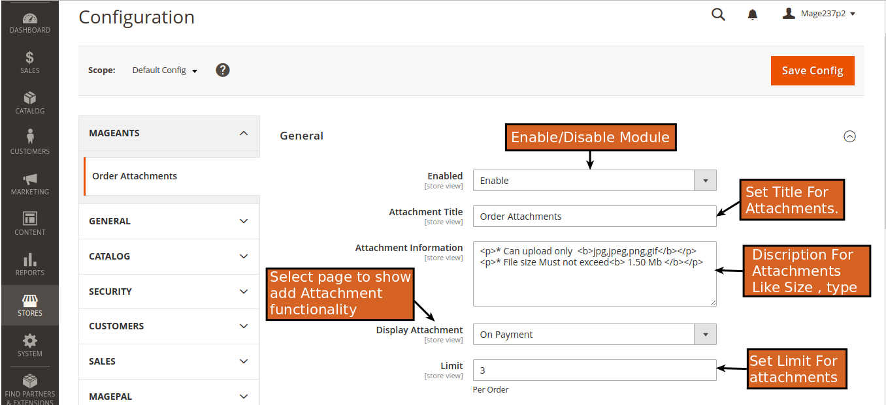

Attachment Title : Set Head Title For Attachment Sections.

Attachment Information : Set Information For Attachments
which is Display on Attachment Section.

Disaplay Attachment : Select Display area for add
Attchments.

Limit : Set Attachment Limit Per Order.

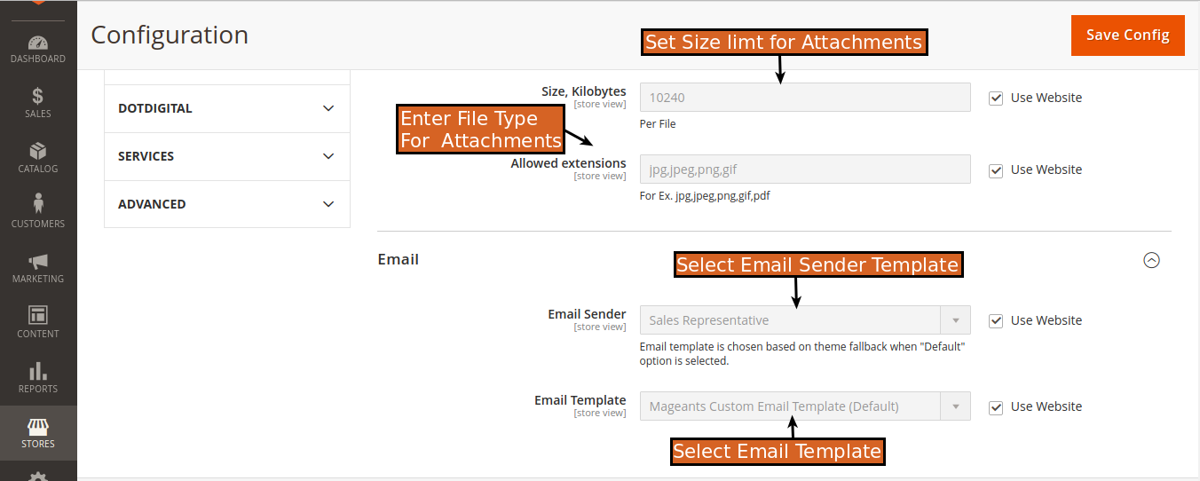

Size Kilobytes : Set Size For Attachments in Kilobytes (KB).

Allowed Extensions : In this field you can Validate the
formate of document.

EMAIL :

Email Sender : Select Sender’s Email template for Mail
transportation.

Email Template : Select Custom Email template
for send E-mail.

=> SALES → Orders → View Order.

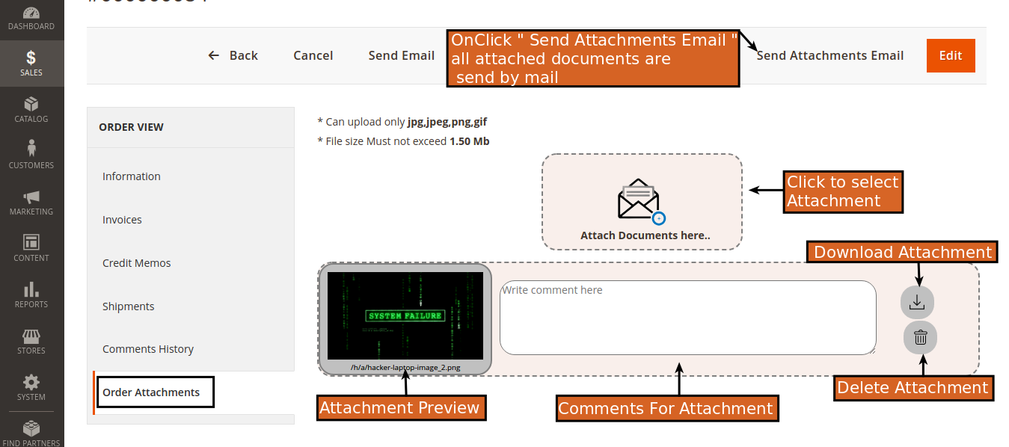

* On Sales Order View you get “ Order Attachment “ tab
on left sidebar.

* In this menu Admin Can See All Attachments of Order.

* Here Admin can Upload new Attachments With comments.

* Admin can see Preview of Attached Documents.

* Admin can Download and Delete Previous
Attachments.

* There is “ Send Attachment Email “ Button in Top
Top navigation bar, On-click on this All Of the Attachment
of particular order will send in E-mail.

Frontend example :

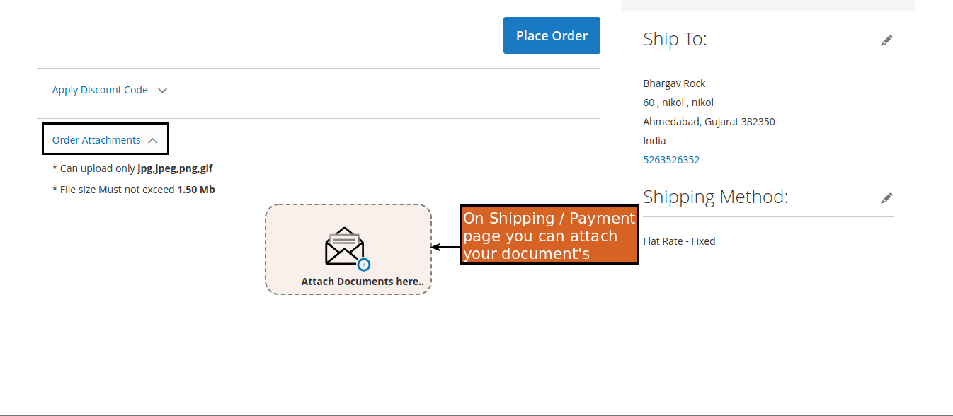
* Checkout Payment page :

* In the Front-end Customer get Attachment selection
functionality in ( Shipment / Payment ) Page. Which was selected in “ Display Attachment “
configuration.

* Customer Account ( My Orders Page ) :

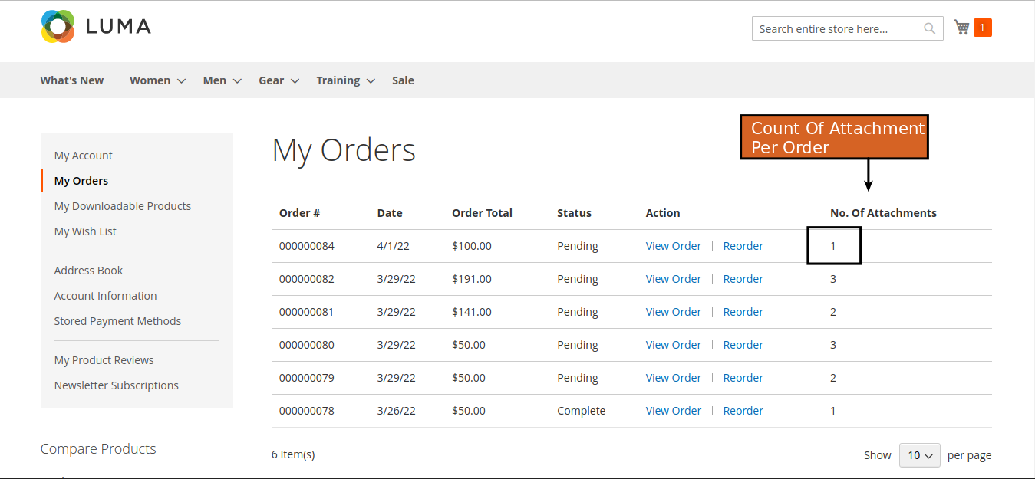

* On Customer Account → My Orders

→ there is Column which is showing the total count of
Attachments in order.

* Customer’s Order View Page :

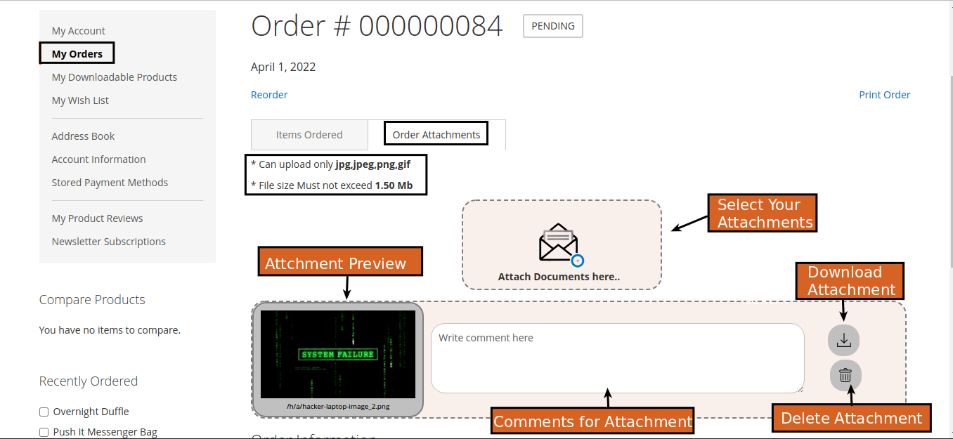

* On particular order view page Customer Can see Uploaded
Attachment.

* If ( Admin/Customer )upload Any New Attachment in previous Order of customer then it is displaying in that
order’s view page.

* Customer can also download and Delete the attachments.

Thank you!
if you have any questions or feature suggestions, please contact us at: https://www.mageants.com/contact-us

Your feedback is absolutely welcome!

